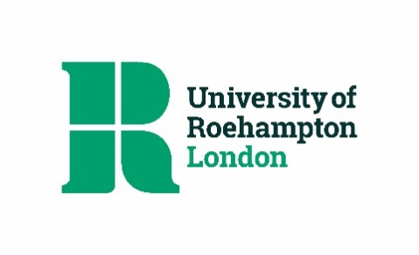
University of Roehampton Privacy Notice – Psychology Short Courses & CPD

This notice sets out how the University uses your personal information. It applies if you are a participant in Psychology Short Courses or University CPD programmes. It should be read in conjunction with the University’s Data Protection Policy.

What personal information will be processed?

The University may store, process or otherwise control the following personal data held on the university eStore:

- Name, e-mail, phone number, address

How your personal data is used by the University

The personal data outlined above will be used to process applications for Psychology Short Courses and CPD, and to administer your record as a participant.

Where you have given your consent, the University will also process your data to send invitations to open days, workshops, and other Psychology Short Courses.

Your data will not routinely be shared with third parties. In certain circumstances the University may share your personal data with other third parties, with or without prior notification, but will only do so in compliance with its legal obligations.

The University will ensure that it has adequate data sharing or contractual agreements in place before any transfers with external parties take place. We will not sell your personal data to third parties under any circumstances, or permit any third parties to sell the data we have shared with them.

Opting out

University will keep a record of your consent. If you would like to withdraw your consent where it has been given, or opt-out of personal data processing, please contact ShortCourses@roehampton.ac.uk.

Please note, in certain circumstances the University may continue to process your personal data, but will only do so in line with its Data Protection Policy.

Storage and retention

Your data will be stored safely and securely. Your data will be held for a period outlined in the University’s Record Retention Schedule.

Rights

Depending on the nature of the processing activity and the legal basis on which it is taking place, you may have one or more rights in respect of your personal data:

- Right of access
- Right to data portability
- Right to rectification
- Right to be forgotten
- Right to request a restriction of processing
- Right to object to processing
- Right not to be subject to automated processing

The University will manage data subject rights access in accordance with its Data Subject Rights Procedure.

Other information

The University will publish any changes we make to this data protection statement on the website, and will and notify you by other communication channels where appropriate.

The University of Roehampton is registered with the Information Commissioner’s Office, and acts as data controller for the personal data outlined in this notice.

You can raise any queries relating to the processing of your personal data with the University’s Data Protection Officer, whose name and contact details are available on the University website.

You have the right to make a complaint about the University’s handling of your personal data to the Information Commissioner’s Office, and can do so at http://ico.org.uk/concerns/.

